University of the Cordilleras

College of Information Technology and Computer Science

Bachelor of Science in Computer Science

Aventory : A Inventory Management System for Small and New Businesses in Baguio City.

Agaser, Claizer Jay

Baltazar, John Marli

Orbino, Michael

Patacsil, Marc

2nd Trimester, SY: 2019-2020

**Chapter 1 : Background of the Study**

**1.1 Introduction**

Baguio city is known as the summer capital of the Philippines meaning that there is a high influx of tourists which gives numerous business opportunities. In a statistic of the Philippine statistics authority in CAR (2017), there are a total of 8,872 businesses that are currently in Baguio City with an average of 8 workers per establishment. There are also benefits in creating a business in Baguio city such as the weather and its environment, meaning that there are numerous businesses that have already been setup here in Baguio city and most businesses are considered small and since there are business opportunities then there are also new businesses. Usually, small and new businesses have a struggle on maintaining their inventory. There is also competition within the business such as Big companies purchase cheap stocks giving small and new businesses a hard time on reselling.

Businesses have responded to competitive pressure by further enhancing their view on inventory as a potential source of cost reduction and production efficiency. Today, companies began to focus more on improving the management of their inventory. Keeping effective inventory is critical especially to those companies that utilizes multiple levels or diverse mixtures of maintenance that demands complex patterns that cannot be comprehended by the capability of the human mind alone.

Focusing on the quantity and mix of inventory materials can increase emphasis that we are placed on the effect of inventory service levels on the ability to meet the target goal, which is to serve the main objective of that specific inventory. Couple of managers have always been faced with dealing with two conflict objectives of inventory management, to provide maximum parts availability while keeping investment low.

In order to improve service quality and efficiency, managers are increasingly looking at new inventory management concepts such as Material Requirements Planning (MRP), Just in Time (JIT), Total Quality Management (TQM) and total cycle time management. Not to mention new inventory management concepts help remove methods that may make the system ineffective and irrelevant. Failing to achieve an effective inventory to meet goals can hurt the organization's purpose.

In order to fully understand and measure the impacts of inventory management on the organization as a whole, increased attention is being paid to identifying new and better ways for measuring performance. The implementation of new and more meaningful indicators of inventor performance coupled with focused emphasis on utilizing materials management concepts adapted from the private sector, present substantial opportunities for transit organizations to improve inventory management and operating efficiency.

It is always important to keep a watchful eye on your inventory, and it is still best to do it properly. With these benefits attached to proper inventory management and control, managers or whomever is in charge can identify and avert any potential inventory challenges and errors. Proper inventory management and maintaining it will provide a good view of the inventory for businesses. A good inventory system will provide visibility of all items on a screen instead of manually checking it on shelves and bins, also the inventory system must prevent stock outs by simply notifying if the stock is running out and if there is a need to replenish. Most businesses rely on inventory since this is their biggest expense, by having an inventory system that properly manages the inventory of a business will have less problem on managing their expenses.

In this paper, the researchers would focus on identifying the problems that small and new businesses face and would talk about the benefits of having a inventory system. The researchers would also provide the functions of the inventory system so that the problems could be identified and if possible solved by using the functions of the inventory system. The researchers would also provide diagrams and models of the inventory management system so that it would provide an overview of the components, functions and entities within the system. Aventory: Inventory Management System provides the basic functions of an inventory management system and it doesn’t have numerous functions to solve all problems in the inventory.

**1.2 Review of Related Literature**

In the studies given, this will show the use and the objectives of an inventory management system mainly on what benefits an inventory management system gives to an organization or company.

Inventory is the complete list of items that a business holds for the goal of resale. As described by Shardeo (2015) about the definition of inventory, inventory also known as stock is defined as goods or materials that a business stores for the sole purpose of reselling or repairing the said goods.  Inventory can also be either scheduled to be sold to some end users or channeled into production of some goods or services. Meaning that maintaining inventory is necessary for businesses since this is the materials needed to run the business and to create profit from it. One of the tools that can help manage and maintain this inventory is inventory management. As stated by Kotler (2000), inventory management refers to all the activities involved in developing and managing the inventory levels of materials so that adequate supplies are available and the costs of over or under stocks are low. And, Inventory management described by Kennedy (2016), it also includes all activities that make certain that consumers have the expected service or product.

It coordinates with the purchase, production and distribution functions of any company or organization to satisfy the advertising and marketing needs and organizational wishes of availing the product to the clients. Inventory management uses a variety of data to keep track of the goods as they move through the process, including lot numbers, serial numbers, cost of goods, quantity of goods and the dates when they move through the process. The data that is used to keep track of the goods is difficult to manage and maintain if traditional inventory management is used, which means that an automated inventory management or an inventory management system is preferred.

Inventory management system is a software system for tracking inventory levels, orders, and deliveries. It can also be used in the manufacturing industry to create a work order, bill of materials and other production related documents. With the features given by the inventory management system we can say that companies today use inventory management systems because this can help reduce work within the company. According to the study of Owoeye et al. (2014) the use of the inventory management system is a need for any manufacturing industry, this helps reduce the use of traditional managing or manual managing and instead use an inventory management system since this is more effective. And also as stated by Smith et al. (2009) in their research paper, Inventory management system is a key instrument for businesses and it can also be used as a tool in other areas such as monitoring trends which benefits the company such as identifying customers desires etc. It is said that inventory management system is a need for every manufacturing company since it has features that can help companies and that this will help companies reduce workload which is one of the problems that the manufacturing industry faces.

There are also benefits of inventory management systems not just for managing inventories, analyzing business data etc. It can also help increase the employment rate. Employment rate is defined as a measure of the extent to which available labor resources. An increase in the employment rate is a good thing since it increases the GDP of a country which helps low income countries. It is more effective if the country has more population since a high employment rate means that most people have a job. Different courses can also be employed in the manufacturing industry mainly in inventory management. According to Alhassan (2013) an inventory management system is generally occasionally being used by the IT & Accounting department of a company, where the IT Department will handle all the maintenance of the Inventory Management System while the Accounting Department will just utilize it. There are also jobs in inventory management that only require a high school diploma at minimum, In the article of Seidler (2018), having a job in inventory control or inventory management means that having a lot of responsibilities. Being responsible and having knowledge on retail or distribution center operations, having strong analytical and math skills and an understanding of software are especially helpful. This means that most jobs in inventory management don't require a college degree since most of the requirements can be self-taught/learned and you simply need experience from it. Since most jobs in inventory management require a high school diploma at minimum employing people is made easy because the requirement needed is not high.

Inventory management systems can be used to develop a company since competition exists in the industry. According to Ngubane et al. (2015) Small Medium and Micro enterprises struggle in development since businesses compete to purchase and sell “cheaper” manufactured products. It is said in the study that the reason why small medium and micro enterprises struggle in the competition, is because they fail to manage their inventory well or that they did not extensively make use of them. Meaning that utilizing inventory management systems benefits businesses in different ways.

Inventory management systems can be used to solve problems in the economy and that companies and different enterprises help increase the economic growth in the country. In the study of Muchaendepi et al. (2019) SMEs or small and medium enterprises are recognized as instruments for economic growth and employment generation but there are still problems such as failure to deliver services to their customers, and they fail to accurately synchronize demand and supply. Inventory management systems are used to avoid such problems and can provide efficiency to the industry. Companies use inventory management software to avoid product overstock and outages. According to Karim et al. (2018) Inventory management is important because it ensures smooth production and prevents loss of sales. And as stated by Sheakh (2018) helps in fulfilling manufacturing problems such as fulfilling the demands, avoiding overstocks etc.

In conclusion, the studies that were given provide information about the use of inventory management systems such as their benefits, use etc. and that there are problems that inventory management can simply solve. By utilizing an inventory management system in any kind of business, this would give the business profits and that major problems can be avoided.

**1.3 Business Rules**

In this part of chapter I, the researchers would show the diagram of the business rules of the proposed inventory management system.

**Figure 2. Business Rules Diagram**

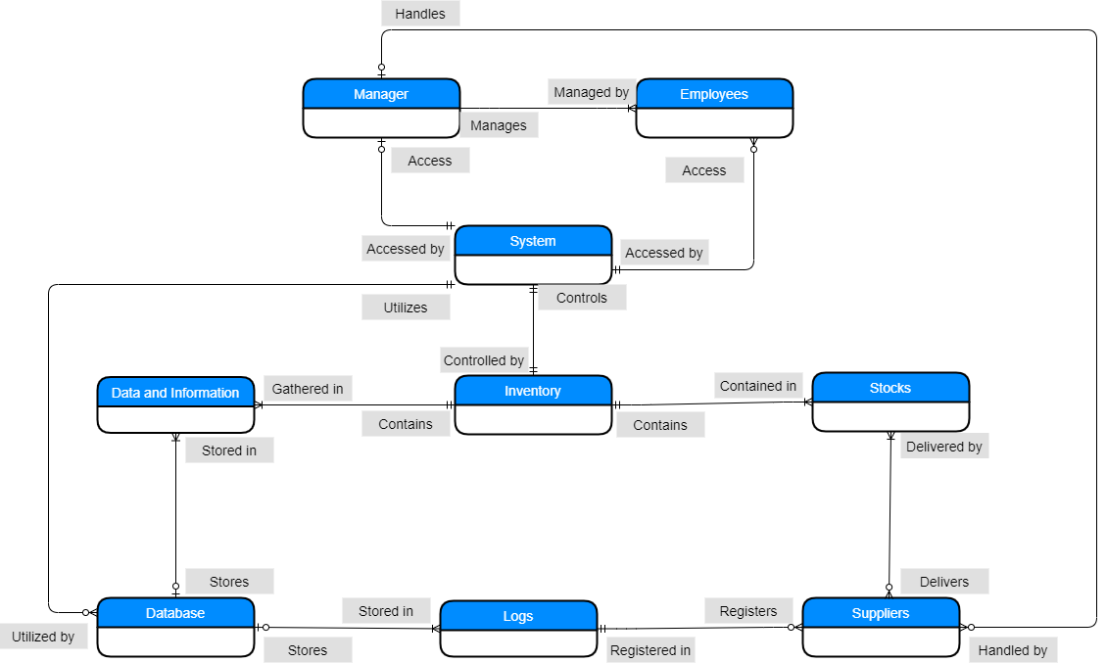

**Narrative definition of the business rules:**

**Manager:**

1. Each Manager manages Many Employees.
2. Each Manager may handle Many Suppliers.
3. Each Manager may access The System.

**Employees:**

1. Each employee is managed by A Manager.
2. Each employee may access The System, which must be authorized.

**System:**

1. A System may be accessed by Each Manager and Each Employees.
2. A System utilizes Many Databases.
3. A System controls Each inventory.

**Inventory:**

1. An Inventory contains Many Data and Information.
2. An Inventory is controlled by A System.
3. An Inventory contains Many Stocks.

**Stocks,Suppliers,Logs,Databases and Data and Information :**

1. Each Stocks is contained by an Inventory.
2. Each Stocks may be delivered by Many Suppliers.
3. Each Supplier delivers Many stocks.
4. Each Supplier is required to register in A Log.
5. A Log registers Each Suppliers that delivers.
6. A Log is stored in Each Databases.
7. Each Database may store Each data and information.
8. Each Database is utilized by the System.
9. Each Data and Information are gathered in An Inventory.
10. Each Data and Information may be stored in Each Databases.

**1.4 Business Process**

**Narrative Description:**

Inventory Management System as an apparatus in taking care of Manufacturing issues in the Industry.

**Purpose/Scope**

To be able to store items that will help take care of Manufacturing issues in the Industry. It will also allow user to check the current inventory

**The creation of account**

1. A manager/employee will now choose between creating a new account or logging in to an existing one.
2. If the employee chooses to create a new account, then he/she will now click on the create button.
3. After clicking the create he/she will now fill up the necessary requirements.
4. After filling up the requirements the employee will click on the ok button to finish creating a new account.

**The creation of a new inventory**

1. The manager/employee will now log in to their accounts
2. After logging in the user will now click on the create a new inventory button
3. The user will fill the necessary requirements,then click the ok button to finish creating a new inventory.

**The storing of items**

1. The manager/employee will log in to the system using a unique ID and password to be able to use the system.
2. After logging in the user will now choose if they plan to store a new item or to check the current status of a current inventory.
3. If the user chooses to store a new item to an existing inventory,the user will now click the store button.
4. The user will now fill up all the necessary requirements.
5. After filling it up the user will now click the store button.

**Figure 2. Business process diagram**

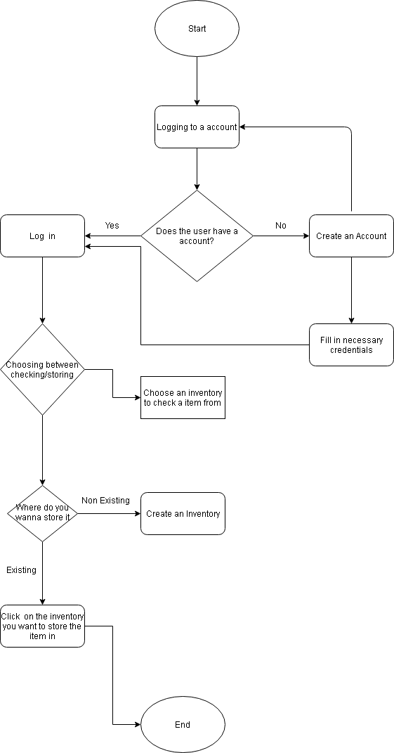

**1.5 Objectives of the Study**

In this part of Chapter 1, the researchers would identify the objectives of the paper.

1. To identify the problem and possible solutions of new and startup businesses.
2. To provide functions of the system.
3. To provide diagrams that could help the researchers understand the system.
4. To identify what the system could solve.

Our Main Objective is to provide a technological inventory system which updates the status and quantity in the inventory that could help new and startup businesses in baguio.

**Chapter 2 : System Analysis**

**2.1 Problems Encountered**

In this part of Chapter 2, the researchers would identify the problems that small and new businesses face on their business.

According to Lorette (n.d.), new and small business owners often have problems balancing the overwhelming demands of the company. The researcher of the study also stated that cost associated with marketing is expensive since big businesses had the foundation meaning that there are competitions.

In an Article of Zarzycki (2020), there are many things a small business must do to keep their inventory under control/manage their inventory. With this small and new businesses must do different kinds of activities to maintain their inventory meaning that it is inefficient.

In a blog of Graham (2006), there are numerous mistakes that could kill a business. Usually new and small businesses only have a single founder, meaning that there is a disadvantage regarding employees working for the owner. There are also problems regarding their profit since they had a hard time tracking their sales.

In this part of Chapter 2, The problems encountered are :

1. Competition.
2. Inefficient maintaining of the inventory.
3. Possible numerous mistakes that could harm the business.
4. Less employees.
5. Hard time tracking sales within the company.

**2.2 Proposed Solution**

In this part of Chapter 2, the researchers would provide solutions for the problems.

1. An Inventory System that could keep track of the changes within the inventory.
2. An Inventory System that is user-friendly and easily understood.
3. An Inventory System that warns the user of overstocking.
4. An Inventory System that warns the user of defects/ unavailable products.
5. An Inventory System that warns the user if the product has less quantity.
6. An Inventory System that has control within the inventory of the company.
7. An Inventory System that has functions that could help the company.

**2.3 Functional and Non-Functional Requirments**

**Figure 3. Functional and Non-Functional Requirements Tabular**

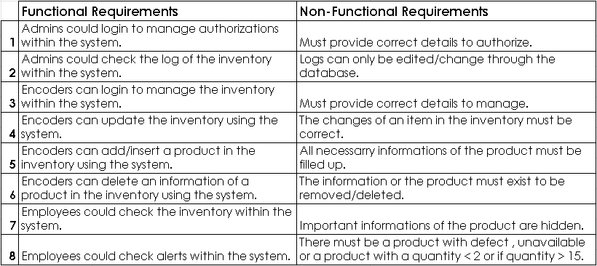

In this part of Chapter 2, the figure shows the Functional and Non-Functional Requirements of the System.

**2.4 Scope and Delimitation**

The Scope of the researchers study is for new and startup businesses here in Baguio. The study will include the functions of the system to identify what can the system do. It is focused on inventory management that a company could use. The study must require a computer with necessary softwares so that the system could be used. This could help and benefit new and startup businesses.

**2.5 Feasibility Analysis**

Technical Feasibility Analysis :

The System can be delivered to different clients by simply sending it to them via. email etc. The System can be used and handled by one or more employees. The employee is only required to know how to handle a computer since the system can be easily understood and is user friendly. The System is not expected to solve all problems of the business but it can solve most of it regarding their inventory.

Requirements for the System :

* The System requires a working computer.
* The System works for any Operating System as long as there’s Java installed.
* To Access the Database, JDBC is required.
* The computer must have some free space.
* The computer is not required to be high end, a low spec. the computer can handle the system.

**Chapter 3 : Methodology**

**3.1 SDLC**

**Figure 4. SDLC Waterfall Model**





ANALYSIS





DESIGN



CODE







TESTING







MAINTENANCE

The researchers used the Waterfall SDLC in our system for a clear step by step of the development and a waterfall model is a sequential model that develops into different phases and each of those development processes have a certain deadline which gives the researchers a clear timeline for the systems development .

**3.2 Decomposition Diagram**

**Figure 5. Decomposition Diagram**

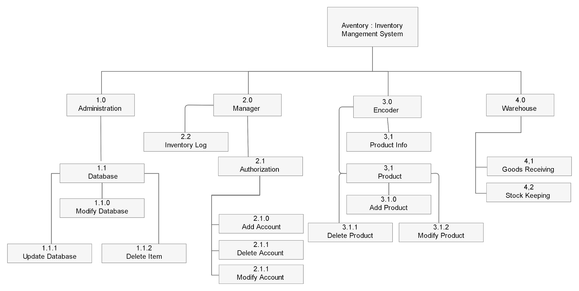

This is the decomposition diagram of Aventory: Inventory Management System, where it shows a complex process, organization etc. that has been broken down into lower level and it is more detailed. An Administration/Administrator has access to the database which can be modified,updated and can delete an item. A Manager can access the inventory log and if authorized, a manager can also add,delete and modify an account. An Encoder can check a product's data, an encoder can also modify,add and delete a product in the inventory. A Warehouse is where the products/stock are being kept and it is also where the goods are being delivered.

**3.3 Context Diagram**

**Figure 6. Context Diagram**

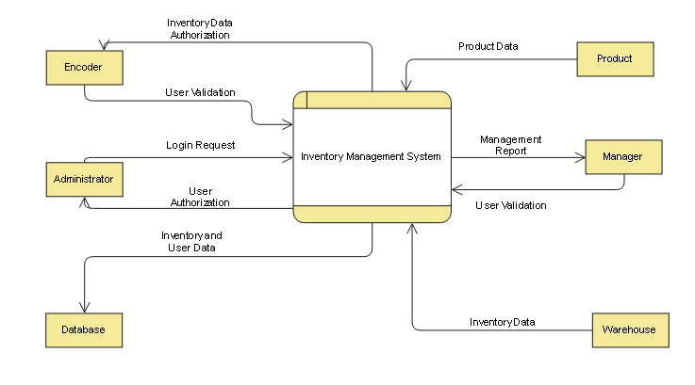

This is the Context Diagram of Aventory: Inventory Management System, this shows the environment of the system and the entities that interact with it. The database entity receives inventory and user data. The Warehouse entity sends inventory data. The Administrator entity provides a login request inorder to receive user authorization. The Encoder entity provides user validation to receive Inventory authorization. The Product entity sends product data. The Manager entity provides user validation to view Management reports.

**3.4 Levels Diagram**

**Figure 7. Level 1 Diagram**

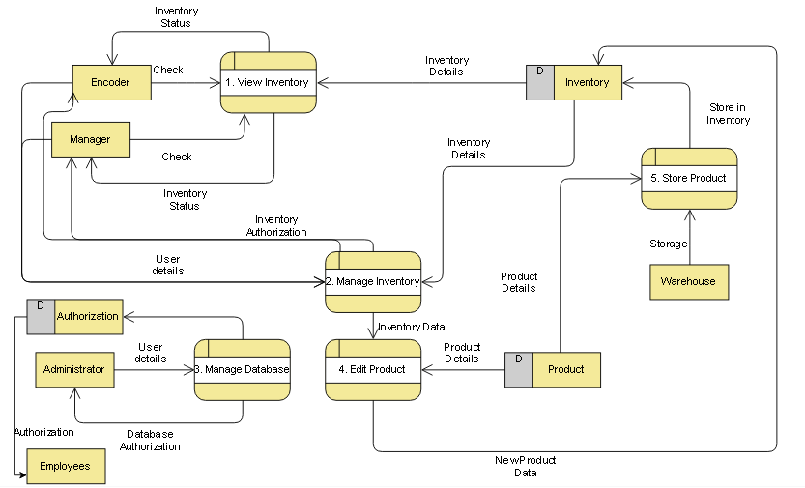

This is a Level 1 or Level 1 DFD Diagram of the Aventory: Inventory Management System, This shows the “exploded view” of the context diagram. In this diagram it shows each of the main sub-processes together which forms the complete system. This also shows the entities on how they interact with the system and this diagram also shows where the data is stored and received.

**3.5 Prototype**

**Figure 8. Prototype Model**

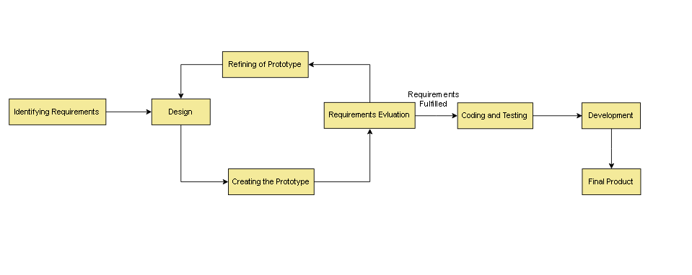

This is the Prototype model we used for our Inventory Management System, The Evolutionary Prototype model uses a continuous, working prototype that is refined after each iteration of customer feedback. But instead of customer feedback, we evaluate if the requirements have been fulfilled or not. If the requirements are fulfilled then this is the time where we code , test and develop our inventory management system.

**Chapter 4 : Conclusions and Recommendation**

Our System the Aventory: Inventory Management System fulfilled the basic needs and can solve most problems that new and small businesses face regarding their inventory. It is also effective since the system contains necessary functions to maintain the inventory of a business. As shown in this research, the system doesn’t contain/provide numerous functions which makes the system not flexible if there will be problems that are difficult to be solved. The system also provides basic security by simply asking for user requirements and validation. The researchers recommend that the system Aventory: Inventory Management System can be used to solve basic problems and that it can be assumed that it won’t solve all problems regarding the businesses inventory.

**REFERENCES**

**[1]** Owoeye, Emmanuel & Adejuyigbe, S.B. & Bolaji, Bukola & Adekoya, Adebayo. (2014). Computerised Inventory Management for a Manufacturing Industry: A case Study in Nigeria. African Journal of Science, Technology, Innovation and Development. 6. 10.1080/20421338.2014.947195.

**[2]** Shardeo, V. (2015). Impact of Inventory Management on the Financial Performance of the firm, IOSR Journal of Business and Management (IOSR-JBM)

**[3]** Ofori, N., Boison, D., Asiedu, E., Afrifah M. (2019). The Effect of Inventory Management on Firm Performance: Controlling for Key Confounding Variables; International Journal of Management and Commerce Innovations.

**[4]** Kotler (2000), Strategic purchasing and supply chain management 2nd edition, Pitman publishing.

**[5]** Kennedy, M. (2016) Effect of inventory Management on Sales Performance A Case Study of National Medical Stores.

**[6]** Khobragade, P., Selokar, R., Maraskolhe, R. (2018) Research paper on Inventory Management System; International Research Journal of Engineering and Technology (IRJET)

**[7]** Alhassan, Y (2013) Inventory Management System Software for Public Universities in Ghana; International Journal of Advanced Research in Computer Engineering & Technology (IJARCET)

**[8]** Smith, R. & Ericson, R. & Millen, S. & Alva, E. & Valdez, M. (2009); Inventory Management Systems; Retrieved from : <https://public.csusm.edu/fangfang/Teaching/HTMmaterial/StudentProjectSpring2009/ReportGroup5.pdf>

**[9]** Karim, Norazira & Nawawi, Anuar & Puteh Salin, Ahmad Saiful Azlin. (2018). Inventory management effectiveness of a manufacturing company- Malaysian evidence. International Journal of Law and Management. 60. 00-00. 10.1108/IJLMA-04-2017-0094.

**[10]** Muchaendepi, W. & Mbohwa, C. & Hamandishe, T. & Kanyepe, J. (2019) Inventory Management and Performance of SMEs in the Manufacturing Sector of Harare; University of Johanesburg.

**[11]** Seidler, K. (2018) Inventory control job description and responsibilities. Retrieved from: <https://losspreventionmedia.com/expectations-in-inventory-control-job-description-and-responsibilities/>.

**[12]** Dr. Ahmed M. (2018) Inventory planning methods

Retrieved from:<https://www.scmdojo.com/importance-of-inventory-management/>

**[13]** Small businesses ideas in Baguio City(n.d) Retrieved from : <https://www.businessnews.com.ph/5-small-business-ideas-baguio-city-20170718/>

**[14]** Doing business in Baguio City (n.d.) Retrieved from : <http://www.gobaguio.com/baguio-business.html#.XmZmmHJKiUk>

**[15]** Lorette, K. (n.d.) Start-Up Business Problems. Retrieved from : <https://smallbusiness.chron.com/start-up-business-problems-653.html>

**[16]** Zarzycki, N. (2020) Inventory Management for Small Business: A Simple Guide. Retrieved from: <https://bench.co/blog/operations/inventory-management/>

**[17]** Graham, P. (2006) Mistakes that kills startups. Retrieved from: <http://www.paulgraham.com/startupmistakes.html>